|  |
| --- |
|  |
| The Documentation |
| [Type the document subtitle] |
|  |
| **[Your Name]** |
| **[Pick the date]** |

[Type the abstract of the document here. The abstract is typically a short summary of the contents of the document. Type the abstract of the document here. The abstract is typically a short summary of the contents of the document.]

Table of Contents

[To update the table of contents, right click the message below and select Update Field (F9 on PC, ⌥⌘U on Mac).]

**No table of contents entries found.**

1. Items
   1. User Interface

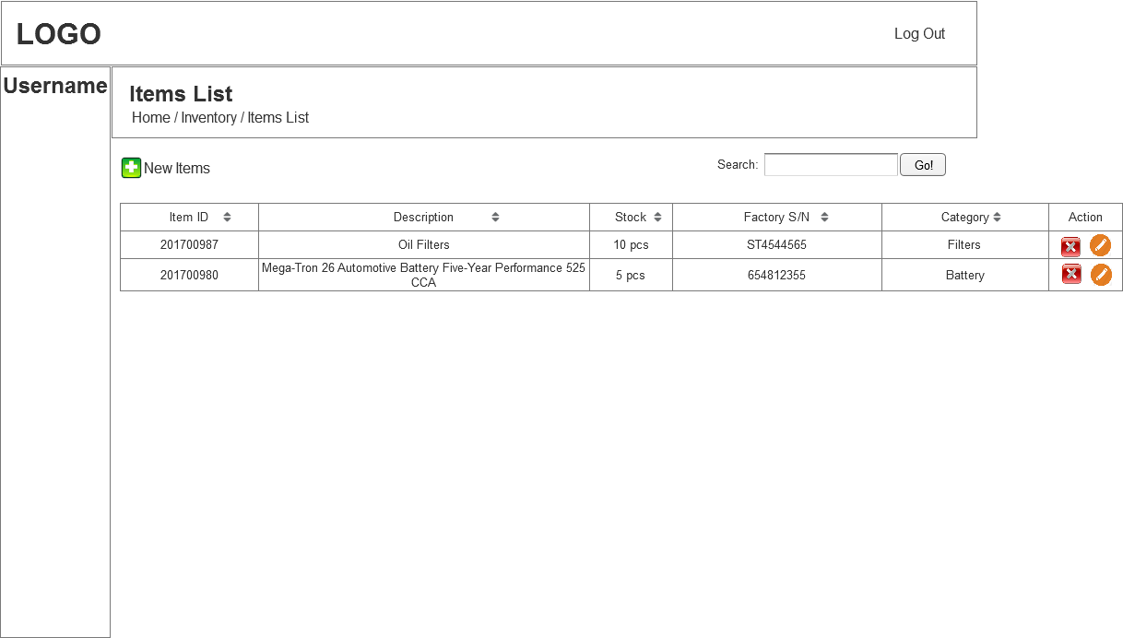

1. Add New Item
   1. User Interface

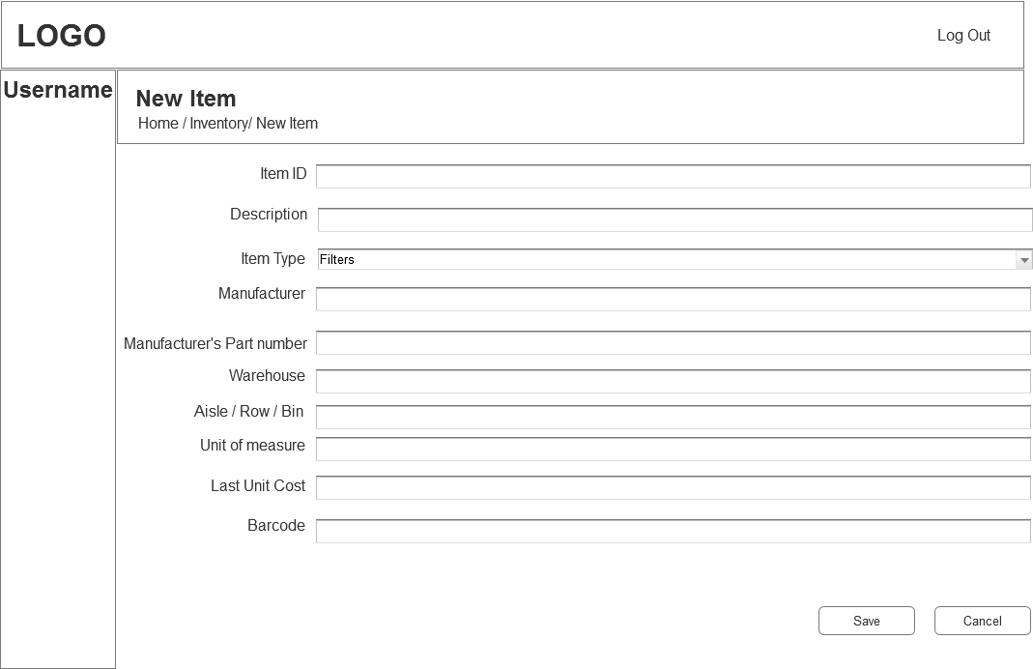

1. Stock Adjusment
   1. User Interface

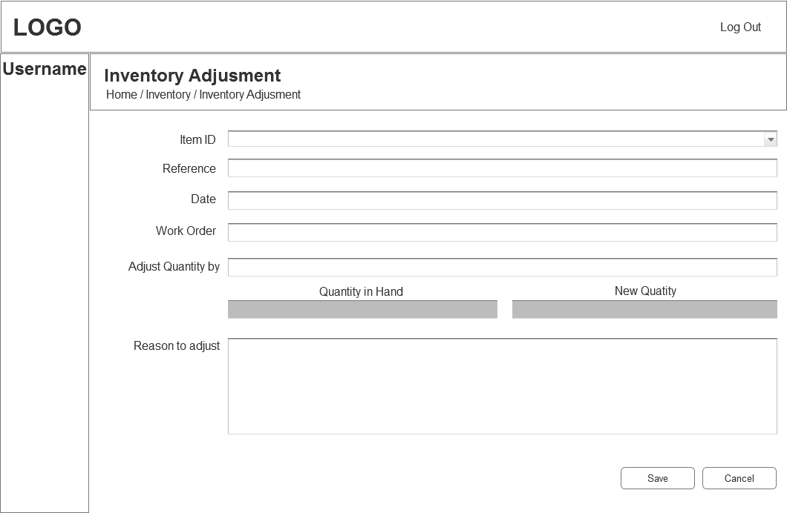

1. Stock Transfer
   1. User Interface

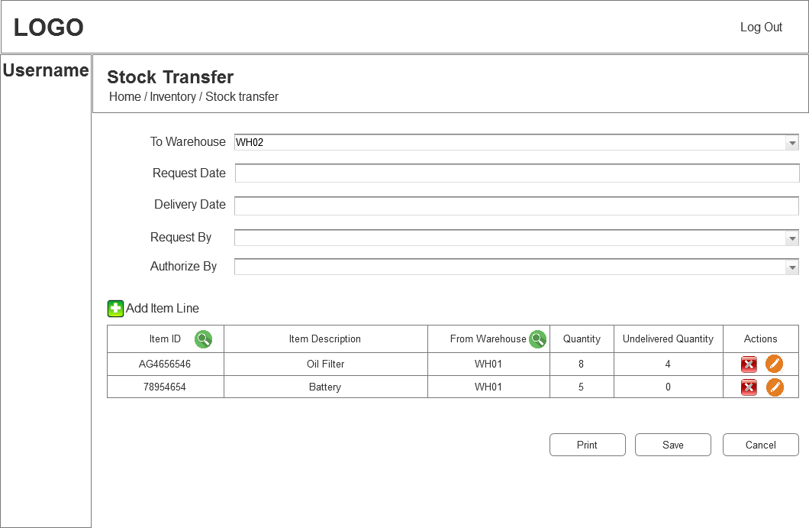

1. Purchase
2. Purchase Order
   1. User Interface

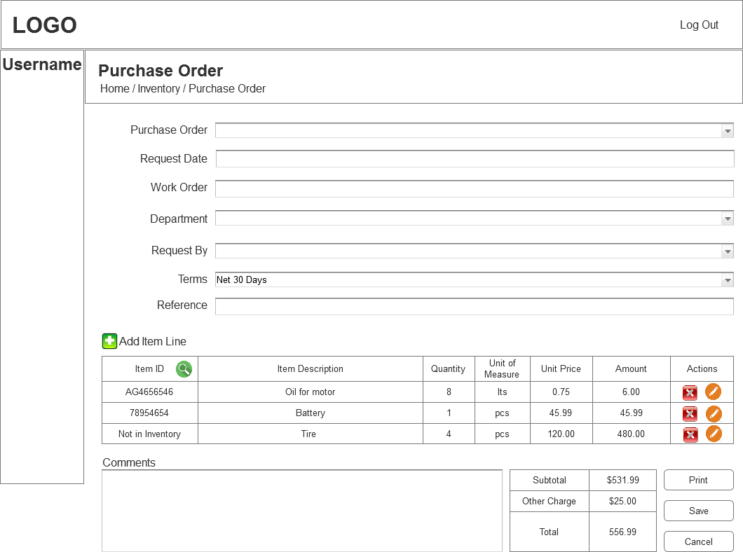

1. Receive Stock
   1. User Interface

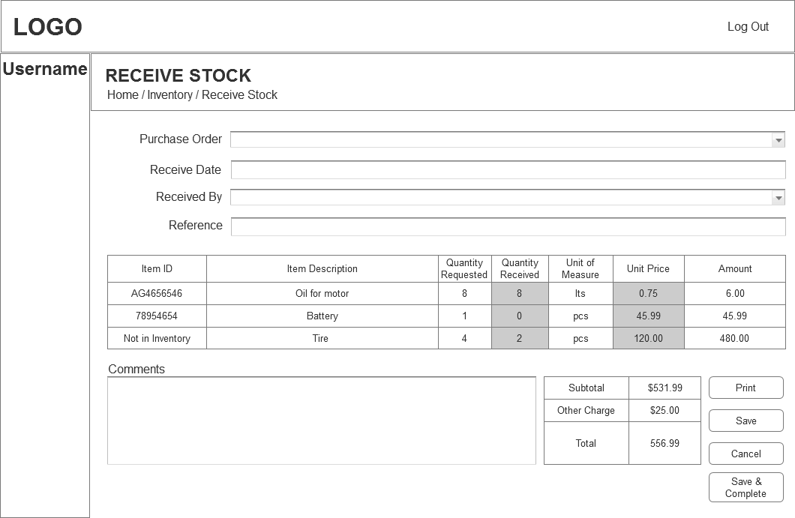

1. Purchase List
   1. User Interface

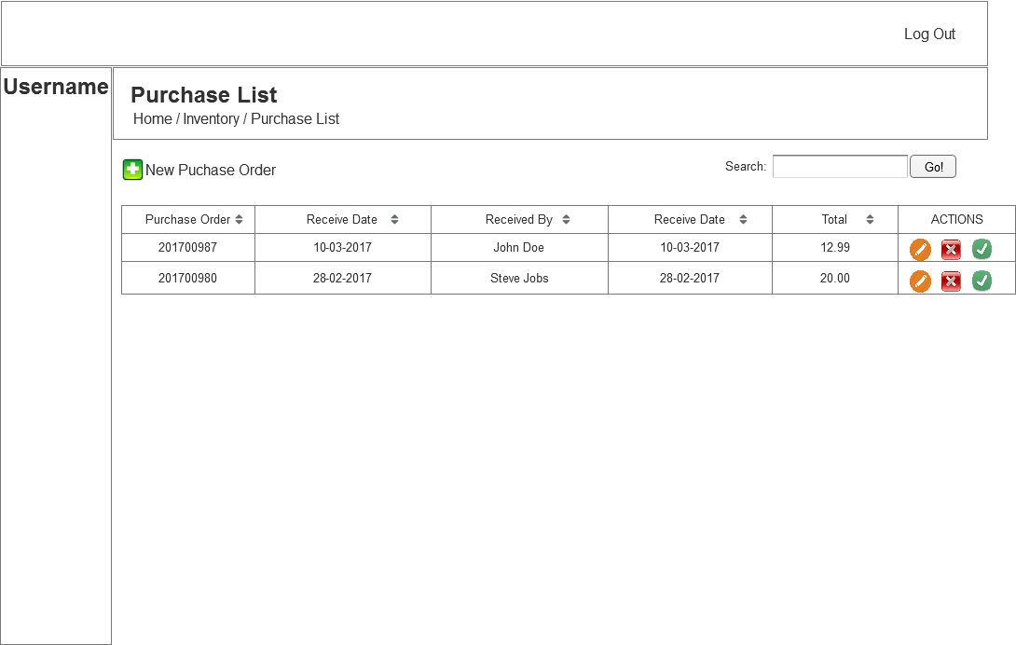

1. Receive List
   1. User Interface

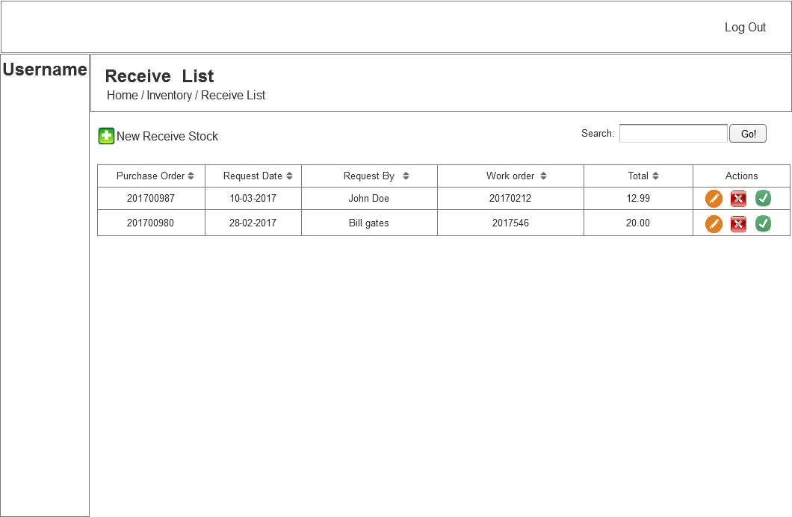

1. Locations List
   1. User Interface

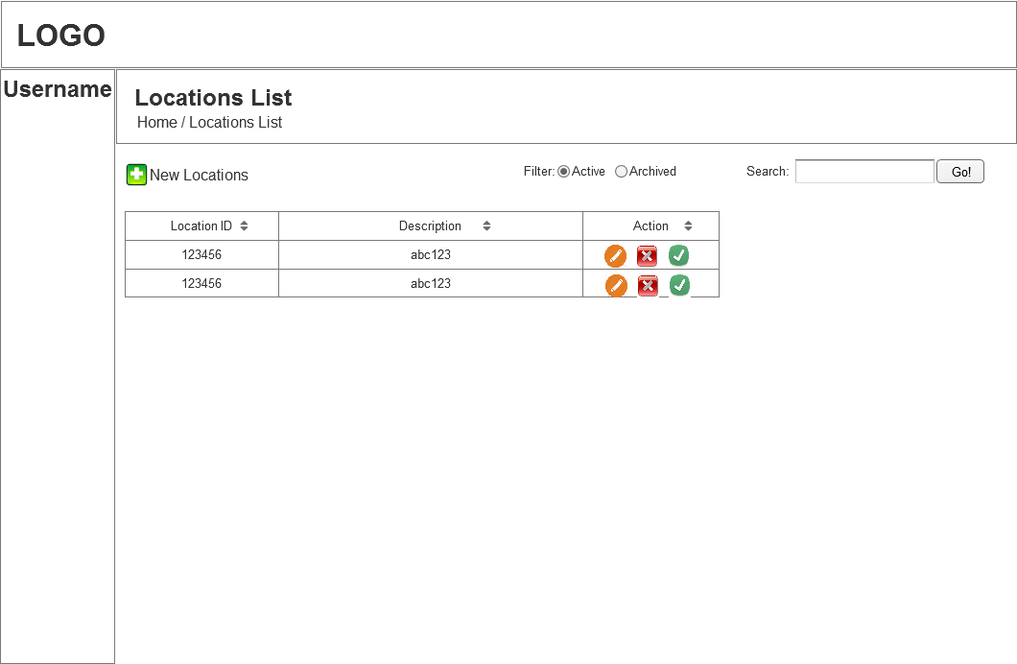

1. Locations
   1. User Interface

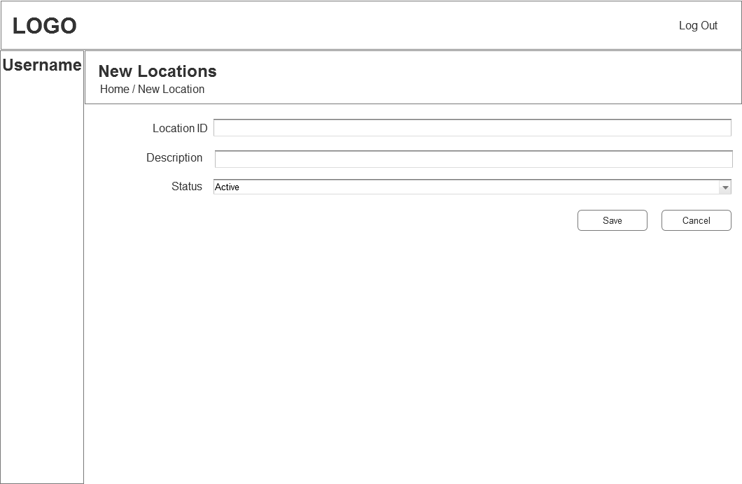

1. Material Requisition
   1. User Interface

